Milindi Shah J057

IOT Exp :

Installation of Raspberry Pi:

Step 1 — Download and Install Raspberry Pi Imager

The first step is to download the Raspberry Pi Imager from the official [Raspberry Pi website](https://www.raspberrypi.org/downloads/). This tool will allow you to choose an OS, have it downloaded automatically, and write it to the SD card of your choice.

**Step 2: Choose OS**

Several operating systems are available for selection within the Raspberry Pi Imager, but we will focus on Raspberry Pi OS.

There are 3 versions of Raspberry Pi OS available. We will briefly touch on each one but we will be using **Raspberry Pi OS (32-bit)**for this guide.

## Step 3: Choose SD Card

You’ll now need your SD card connected to your computer to copy over the OS you chose

**Step 4: Write to SD Card**

This step will write the selected OS to the SD card and run a verification that the copy was successful.

## Step 5: Booting Your Raspberry Pi

Insert your microSDHC card into your Raspberry Pi. Then, hook up your Raspberry Pi to power, keyboard, mouse, and monitor.

Step 6 :Configure Raspeberry Pi Username and Password

The next screen will prompt you to change your password. The default username is “pi” and the default password is “raspberry”

**Programming with GPIOZero/any other library**

Q1. Turn LED on when object is at proximity, off otherwise:

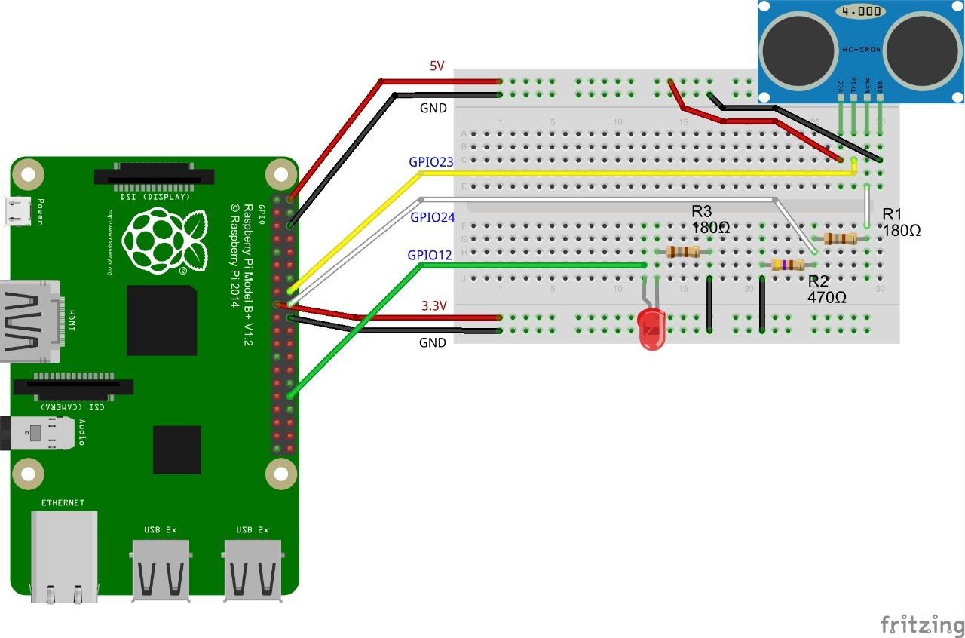

**from gpiozero import DistanceSensor, LED**

**from time import sleep**

 led = LED(4)

**sensor = DistanceSensor(4,17)**

**while True:**

**if sensor.distance<5:**

**led.on()**

**else:**

**led.off()**

**sleep(1)**

Q2. Turn LED on based on light intensity:

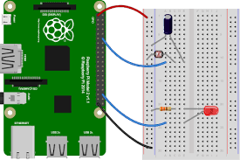

**from gpiozero import LightSensor, PWMLED**

**from signal import pause**

**sensor = LightSensor(17)**

**led = PWMLED(4)**

**led.source=sensor**

**pause()**

Q3. Create LED chaser:

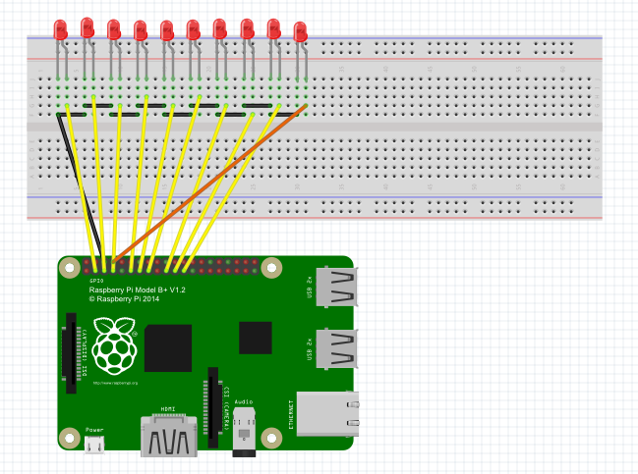

from gpiozero import LED

from time import sleep

led1 = LED(2)

led2 = LED(3)

led3 = LED(4)

led4 = LED(17)

led5 = LED(27)

led6 = LED(22)

led7 = LED(10)

led8 = LED(9)

led9 = LED(11)

led10 = LED(14)

x = 0.2

while True:

led1.on()

sleep(x)

led1.off()

led2.on()

sleep(x)

led2.off()

led3.on()

sleep(x)

led3.off()

led4.on()

sleep(x)

led4.off()

led5.on()

sleep(x)

led5.off()

led6.on()

sleep(x)

led6.off()

led7.on()

sleep(x)

led7.off()

led8.on()

sleep(x)

led8.off()

led9.on()

sleep(x)

led9.off()

led10.on()

sleep(x)

led10.off()

Q4. When button is pressed open servo motor shaft:

**from gpiozero import Servo, Button**

**servo = Servo(17)**

**btn = Button(4)**

**while True:**

**servo.min()**

**btn.wait_for_press()**

**servo.max()**

**btn.wait_for_press()**

Q5. Traffic signal in RPi:

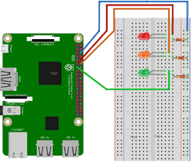

from gpiozero import TrafficLights

from time import sleep

lights = TrafficLights(2, 3, 4)

lights.green.on()

while True:

sleep(10)

lights.green.off()

lights.amber.on()

sleep(1)

lights.amber.off()

lights.red.on()

sleep(10)

lights.amber.on()

sleep(1)

lights.green.on()

lights.amber.off()

lights.red.off()

Q6. RGB LED controlled by three button, one for each color:

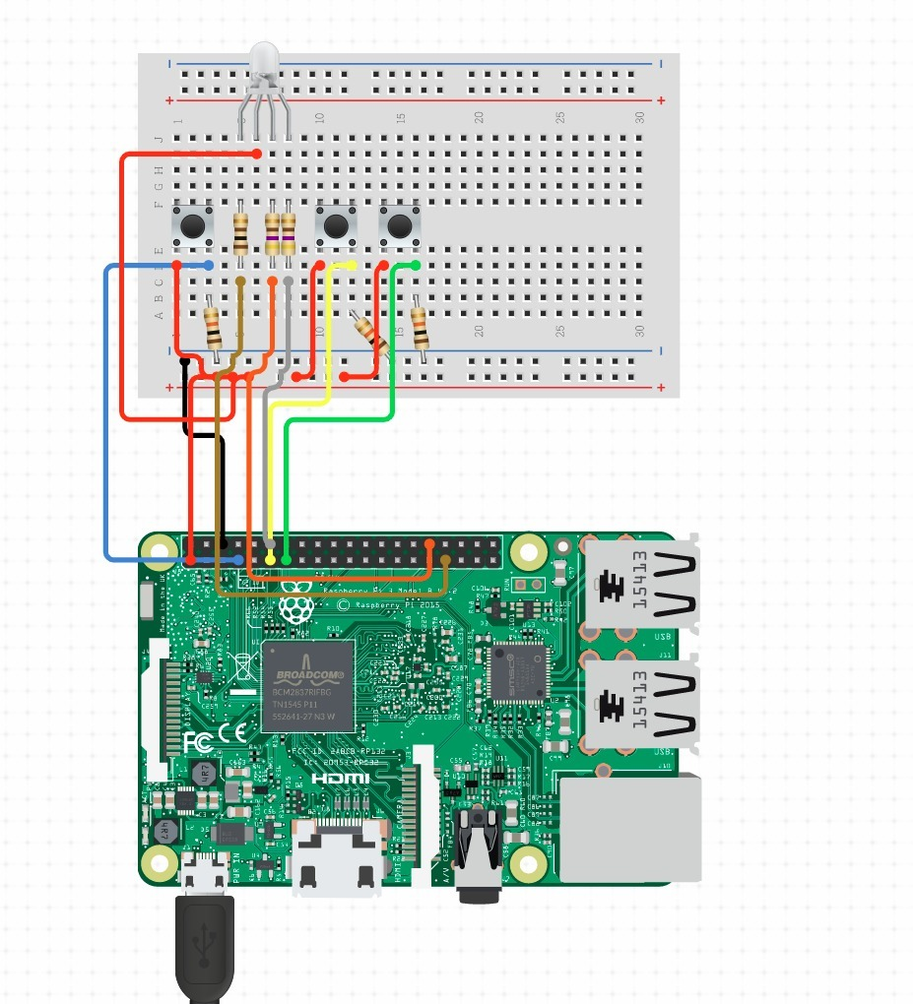

from gpiozero import RGBLED, Button

from time import sleep

led = RGBLED(red=9, green=10, blue=11)

red_button = Button(2)

blue_button = Button(3)

green_button = Button(4)

if red_button.is_pressed:

led.red = 1

if green_button.is_pressed:

led.green = 1

if blue_button.is_pressed:

led.blue = 1

Q7. Turn LED on if motion is detected:



from gpiozero import LightSensor

from signal import pause

sensor = LightSensor(18)

led = LED(4)

sensor.when_light = led.off()

sensor.when_dark = led.on()

Q8. Make robot go in a square:

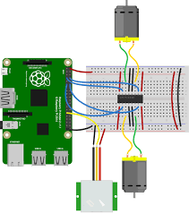

**from gpiozero import Robot**

**robot = Robot(left=(1,2), right=(3,4))**

**while True:**

**robot.forward()**

**sleep(10)**

**robot.backward()**

**sleep(10)**